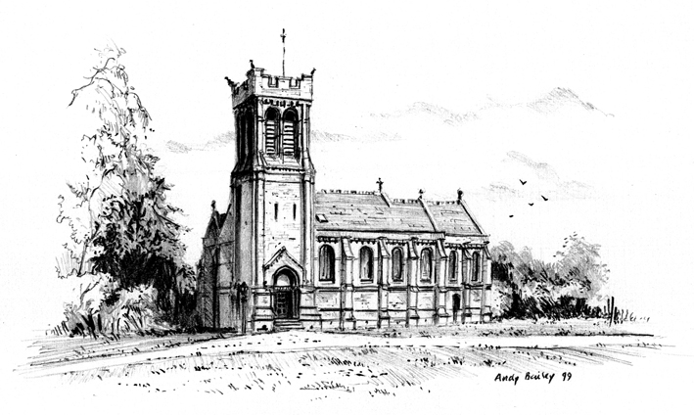

St Mary's Church Woburn
www.woburnparishchurch.org.uk

Wedding Information

Rector of the Benefice:
The Reverend Stephen Nuth
The Vicarage
Park Street
Woburn, Bedfordshire
MK17 9PG

01525 290225

rectornuth@gmail.com

Wedding Administrator

Ian Wayment

woburnweddings@gmail.com

07885 756114

INTRODUCTION

Thank you for enquiring about having your marriage service at St Mary's Church. We hope that the following information will help you decide if you want to progress with that decision.

Please read the following notes carefully, if you have any questions, I am more than happy to answer them.

On the next few pages you will find Information on the following topics: -

- Can we get married at St Mary’s?
- Wedding Fees
- Pre-Marriage Course

With very best wishes.

Ian Wayment

Wedding Administrator

07885 756114
woburnweddings@gmail.com

MAY 2021

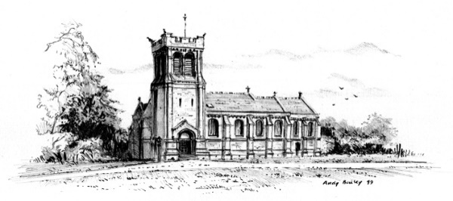

Can we get married at St Mary’s?

To be married at St Mary’s (or any Church of England church) there are a few “rules” that need to be met. These are:

- You must have a Qualifying Connection (QC) with the church. How you get this is explained below.
- If either or both of you have been married before you will need to discuss the circumstances with our Vicar.
- If you are a British or Irish Citizen or have either ‘settled’ or ‘pre-settled’ status under the EU Settlement Scheme you can be married in church after Banns have been read or a Common Licence obtained. If you don’t meet those requirements you will need to make a special application via a Registry Office and this can take up to 70 days to administer.

Qualifying Connection – what it is and how to obtain one

To be married in a parish church the rules of the Church of England are that you need a Qualifying Connection (QC) with that church. You have a QC if any of the following apply to either partner
- You were baptised in the parish.
- You had your confirmation entered in a church register book of a church or chapel in the parish;
- has at any time had your usual place of residence in the parish for at least 6 months;
- Your parents have at any time during their lifetime had their usual place of residence in the parish for at least 6 months;
- You have attended the church on a regular basis (at least once a month) for the six months leading up to your wedding.
Most couples will need to use the last option to obtain a QC.

PLEASE NOTE IT IS A LEGAL REQUIREMENT THAT YOU HAVE A QUALIFYING CONNECTION. IF YOU NEED TO OBTAIN THIS BY ATTENDING REGULARLY FOR 6 MONTHS PLEASE THINK CAREFULLY ABOUT THIS. IT IS A BIG COMMITMENT AND YOU SHOULD ONLY DECIDE TO GO AHEAD WITH YOUR WEDDING AT ST. MARY’S IF YOU ARE WILLING AND ABLE TO UNDERTAKE IT.

The services you will need to attend are either the 9 a.m. or 10.30 a.m. Sunday morning service at
St Mary’s Woburn.

Wedding Fees

Like all other matters related to weddings there are costs involved and the table below sets out the fees payable for weddings at St Mary’s Woburn.

Wedding Service Fee. This is the national standard wedding fee which is charged at all Church of England churches. | £495
Banns – reading of Banns and issue of Banns certificate at your local church. | £46
Verger. The Verger looks after the setting up and opening and closing of the church on the day of your wedding and assists as necessary with arrangements during the service. | £55
Organ hire, Optional | £50
Organist. Optional | £110
Organist additional fee if you have booked a visiting choir – this covers the organist’s time involved in liaison with choir, learning music, rehearsal time. | £50
Organist fee if you want your own organist – this covers time of the church organist involved in liaison and meet up and practice with visiting organist. | £50
Heating. Only charged for weddings between 1st Oct – 30 April | £110
Bells. Optional. This covers hire of the bells plus fees paid to the eight bellringers. | £330
Hand delivery of Marriage Document to Registry office. This covers the time and mileage of person carrying out the delivery. | £30

Pre- Marriage Course

Attending this course is a requirement for those couples who plan to marry at St Mary's Woburn and St John the Baptist Eversholt. For 2022 it will run in January or February.

The course includes 5 informal sessions and follows the Pre- Marriage Course DVD.

It is important for you both to attend so that together as a couple you can consider the issues raised.

Over the 5 sessions, you will learn about important tools that will enable you to make your marriage work. They will include: -

● the importance of commitment;
● how to recognise and appreciate your differences;
● the art of communication;
● resolving conflict;
● the importance of spending time together;
● nurturing your friendship;
● making each other feel loved;
● developing a good sexual relationship;
● the importance of talking about your goals, values, ambitions and hopes.

The course leaders are George & Sarah Atkinson-Clark, but please contact myself for any details about the course.

You will receive a separate invitation to this course when you book your wedding.

Ian Wayment
Wedding Administrator
May 2021

